**Desktop Assistant :**

**A.I.S.H.A. ( Artificial Intelligence Simulated Humanoid Assistant )**

Submitted in partial fulfillment of the requirements for the award of degree of

**BACHELOR OF ENGINEERING**

**IN**

**COMPUTER SCIENCE & ENGINEERING**



**Submitted to:**

**Tanu Dhiman**

**Submitted By:**

**Kumar Arjun-18BCS1554**

**Ojas Bhimta-18BCS1569**

**Danish Mehra-18BCS1564**

**Abhi Pathania-18BCS1574**

**DEPARTMENT OF COMPUTER SCIENCE & ENGINEERING**

**Chandigarh University, Gharuan**

**INTRODUCTION**

Who doesn't want to have the luxury to own an assistant who always listens for your call, anticipates your every need, and takes action when necessary? That luxury is now available thanks to artificial intelligence-based voice assistants.

Voice assistants come in somewhat small packages and can perform a variety of actions after hearing your command. They can turn on lights, answer questions, play music, place online orders and do all kinds of AI-based stuff.

Voice assistants are not to be confused with virtual assistants, which are people who work remotely and can, therefore, handle all kinds of tasks. Rather, voice assistants are technology based. As voice assistants become more robust, their utility in both the personal and business realms will grow as well.

A **voice assistant** or **intelligent personal assistant** is a software agent that can perform tasks or services for an individual based on verbal commands i.e. by interpreting human speech and respond via synthesized voices. Users can ask their assistants’ questions, control home automation devices, and media playback via voice, and manage other basic tasks such as email, to-do lists, open or close any application etc with verbal commands.

Let me give you the example of [Braina (Brain Artificial)](https://en.wikipedia.org/wiki/Braina" \t "https://towardsdatascience.com/_blank) which is an intelligent personal assistant, human language interface, automation and **voice recognition software** for Windows PC. Braina is a multi-functional AI software that allows you to interact with your computer using  in most of the languages of the world. Braina also allows you to accurately convert speech to text in over 100 different languages of the world.

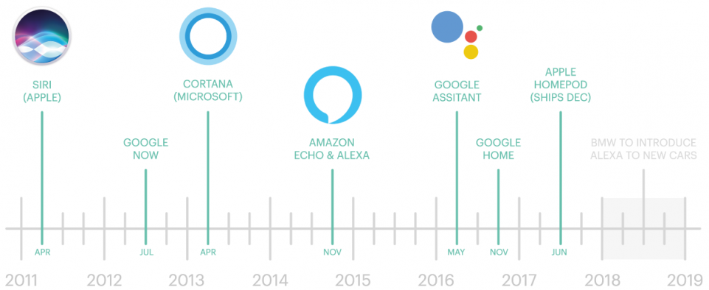

In recent times, Voice assistants got the major platform after Apple integrated the most astonishing Virtual Assistant — Siri which is officially a part of Apple Inc. But the timeline of greatest evolution began with the year 1962 event at the Seattle World Fair where IBM displayed a unique apparatus called Shoebox. It was the actual size of a shoebox and could perform scientific functions and can perceive 16 words and also speak them in the human recognizable voice with 0 to 9 numerical digits.

During the period of the 1970s, researchers at Carnegie Mellon University in Pittsburgh, Pennsylvania — with the considerable help of the U.S Department of Defence and its Defence Advanced Research Projects Agency (DARPA) — made Harpy. It could understand almost 1,000 words, which is approximately the vocabulary of a three-year-old child.

Big organizations like Apple and IBM sooner in the 90s started to make things that utilized voice acknowledgment. In 1993, Macintosh began to building speech recognition with its Macintosh PCs with PlainTalk.

In April 1997, Dragon NaturallySpeaking was the first constant dictation product which could comprehend around 100 words and transform it into readable content.

**FEASIBILITY STUDY**

According to the overall description in the context, the purpose of the project is to develop an Android application that provides an intelligent voice assistant with the functionalities as calling services, message transformation, mail exchange, alarm, event handler, location services, music play service, checking weather, searching engine (Google, Wikipedia), camera, Bing translator, Bluetooth headset support, help menu and Windows azure cloud computing.

The main objective for developing this system is to make an AI that not only responds to the common queries but advancing it to understand the emotions of a person by the words he/she are using.To make a common person familiar with AI is our basic approach.To understand how we can progress further with ML and Python combination and further enhancing our field of vision in this expertise.

**FUTURE SCOPE:**

Throughout the history of computing, user interfaces have become progressively natural to use. The screen and keyboard were one step in this direction. The mouse and graphical user interface were another. Touch screens are the most recent development. The next step will most likely consist of a mix of augmented reality, gestures and voice commands. After all, it is often easier to ask a question or have a conversation than it is to type something or enter multiple details in an online form.

The more a person interacts with voice-activated devices, the more trends, and patterns the system identifies based on the information it receives. Then, this data can be utilized to determine user preferences and tastes, which is a long-term selling point for making a home smarter. Google and Amazon are looking to integrate voice-enabled artificial intelligence capable of analyzing and responding to human emotion.

**METHODOLOGY**

Apart from the project itself, there is also some investigation works on the existed products in this area and the tendency of voice product, personal assistant developing. Two products were mainly investigated that are popular and representative, the English product of “Siri”.The investigation focus on how those ideas originated; what functionalities and services they have; how they provide these services to the customers; test the product and related functions to get the architect, structure, logical algorithms of those products; how they spread and promote the product in marketing; and how they refine and upgrade the products from different versions.

**Module & Team Member wise Distribution of work**

Coding and module integration part is assigned to Kumar Arjun ( 18BCS1554 )

and Abhi Pathania ( 18BCS1574 ).

Research of architecture and intents is assigned to Ojas Bhimta( 18BCS1569 ).

And all the documentation is to be done by Danish Mehra ( 18BCS1564 ).

**INNOVATION IN THE PROJECT**

The main innovation in the existing model is to make it suitable for sentimental analysis.

It will provide a feature of mod based chat with the assistant.

Sentiment analysis is a common Natural Language Processing (NLP) task that can help you sort huge volumes of data, from online reviews of your products to NPS responses and conversations on Twitter.

However, implementing a machine learning solution on your own can be a daunting task that requires data scientists.

You will need to gather quality data to train the models, source some hardware (maybe even GPUs) to run your software on, and test relentlessly to get a data analysis solution that works. Once you’ve built your model  – and it works– more resources are needed to integrate the new module into your existing solution, to maintain it and to keep it updated.

**SOFTWARE REQUIREMENTS:**

System requirements: Python 2.7, Spyder IDE, MacOS Mojave(version 10.14)

Install all these python libraries :

pip install [SpeechRecognition](https://pypi.org/project/SpeechRecognition/" \t "_blank)  
pip install [beautifulsoup4](https://pypi.org/project/beautifulsoup4/" \t "_blank)  
pip install [vlc](https://pypi.org/project/beautifulsoup4/" \t "_blank)  
pip install [youtube-dl](https://pypi.org/project/youtube_dl/" \t "_blank)  
pip install [pyowm](https://pypi.org/project/pyowm/" \t "_blank)  
pip install [wikipedia](https://pypi.org/project/wikipedia/" \t "_blank)

**HARDWARE REQUIREMENTS**

* I3 processor or above.
* 1 Gb ram.
* Working Computer System.

**BIBLIOGRAPHY**

* <https://opensource.com/article/19/4/social-media-sentiment-analysis-python>
* <https://cloud.google.com/natural-language/docs/sentiment-tutorial>
* <https://pythonprogramming.net/sentiment-analysis-python-textblob-vader/>
* <https://dev.to/coderasha/build-virtual-assistant-with-python-automate-tasks-46a6>
* <https://docs.microsoft.com/en-us/azure/cognitive-services/speech-service/index-voice-assistants>